<https://www.tutorialspoint.com/spring/spring_environment_setup.htm>

**Review about how to config Spring environment to use with eclipse**

1. First, you need to request Your Temporary Admin Rights. Follow my step to do it.

Access to your IT Workplace Toolkit by Click to this Icon on your Start Menu Bar



The IWT window will show up, then Click on Request Temporary Admin Rights

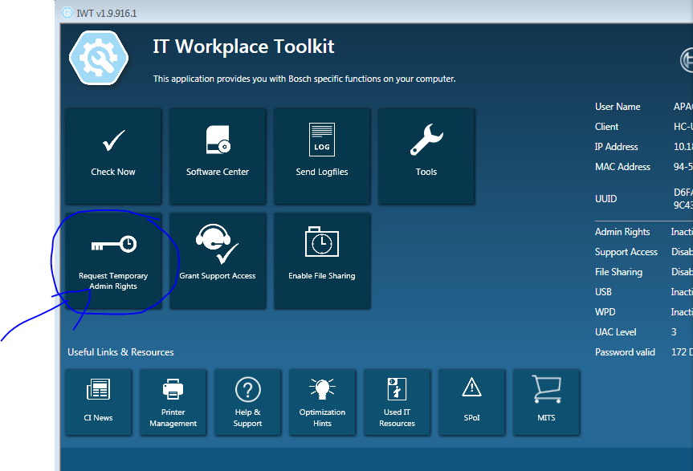

A new page will open in IE, Click Order button

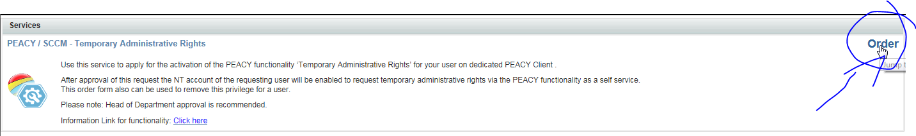

Number 1: click here and choose your computer

Number 2: Click here and choose Yes

Number 3: Click here to submit your order

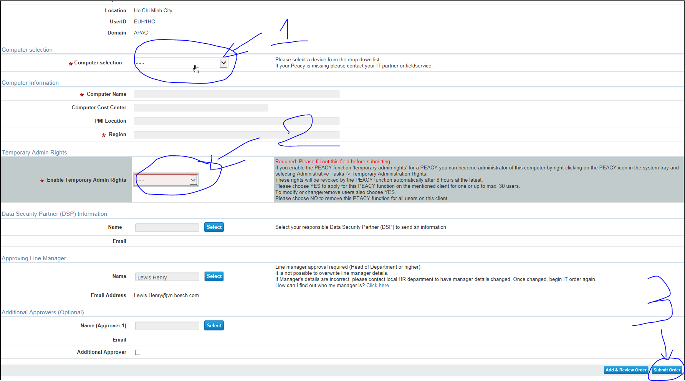

Then wait until you receive a letter said that the Temporary Admin Rights have been granted successfully.

1. Why you are waiting to get the Temporary Admin right , go to these website to download :

<http://www.oracle.com/technetwork/java/javase/downloads/index.html>

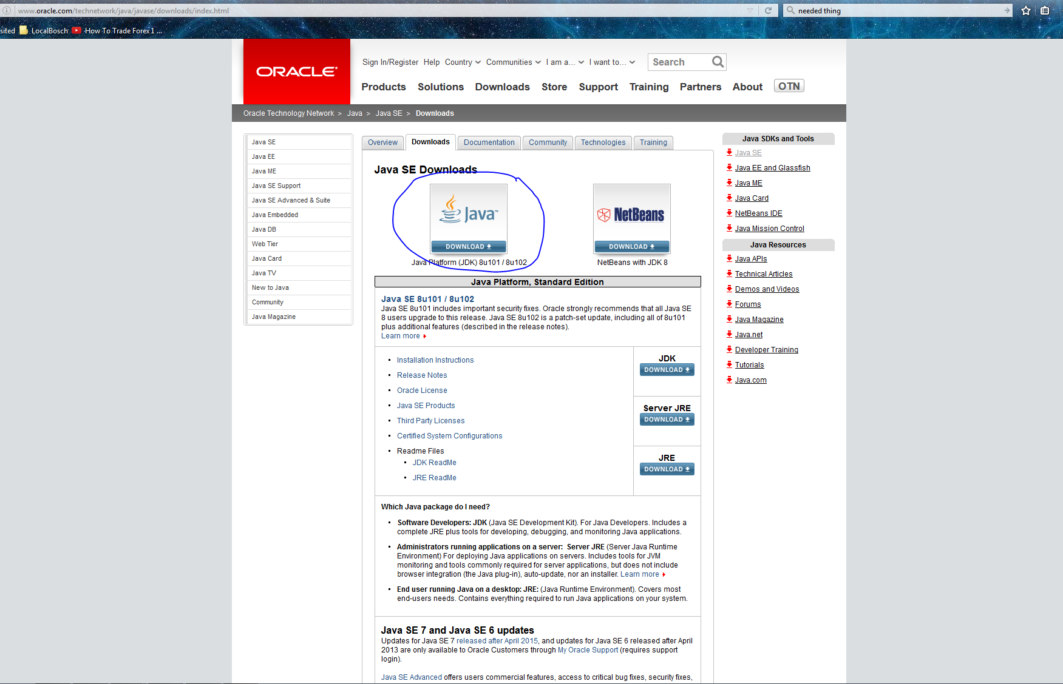

Accept the License Agreement and choose the product suitable for your computer.

In this case our computer using Wins x64 so download the product just like the image below

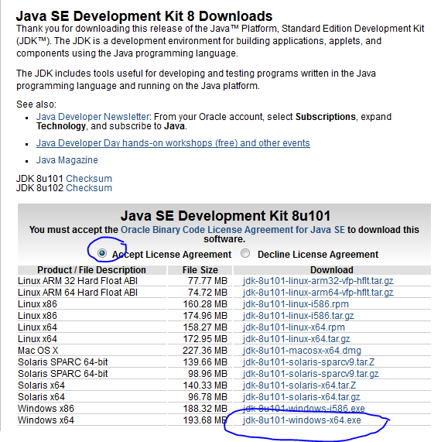

Then go to this website to Download Spring Tools Suite

<https://spring.io/tools/sts/all>

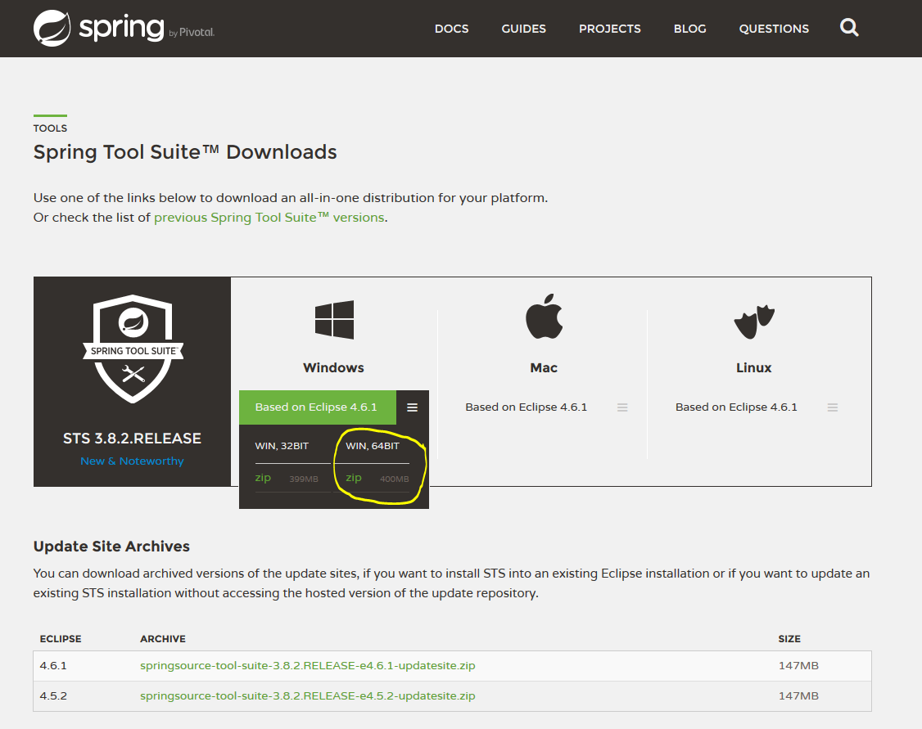

Download the version that suitable for your computer. Because in Bosch we’re using wins x64 so we should download this version.

1. While the STS download, Active your Temporary Admin Right if you already receive a complete letter from CI, If you don’t have, just keep this step and do it later when you have.

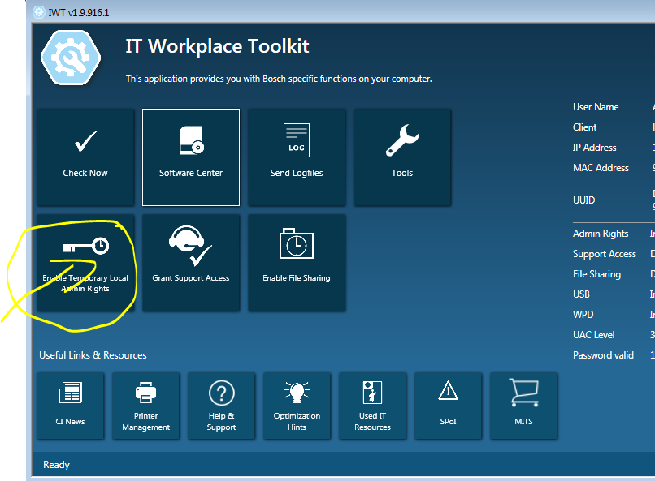

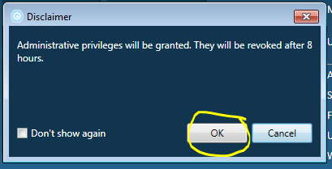

After Click ok, you have a popup window to choose reason, choose a reason for yourself, ok, then relogin your user by log off then log on again.

After you log on, run JDK Setup



1. Extract STS zip file -> open that folder -> sts-bundle folder -> sts-3.8.2.RELEASE folder -> open STS.exe 

**Configure Proxy For Eclipse or STS to get GIT and TFS plugin thought Bosch proxy**

1. Download Eclipse from <http://www.eclipse.org/downloads/> . In BOSCH you should to use portable version.
2. Extract zip file and then open Eclipse.exe



1. At the menu bar, click on menu Window , the click on menu Preferences like the image below

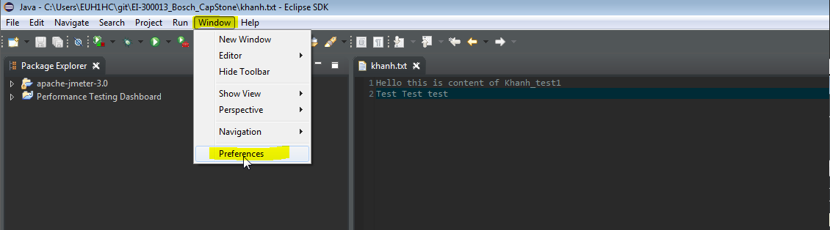

1. At the Preferences window, we click on tab General , then choose tab Network Connections

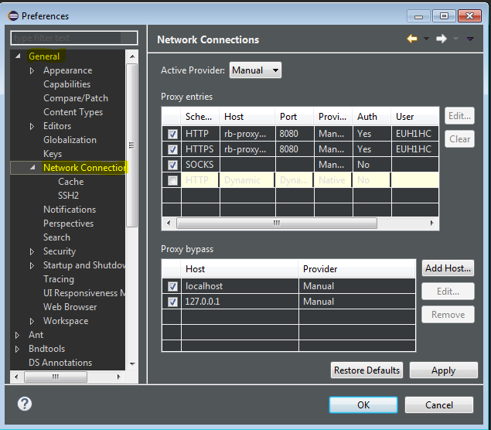

1. Click on the dropdown menu “Active Provider” and choose Manual just like the image above
2. Click on the first row then click Edit Button in the right side to set proxy for HTTP method

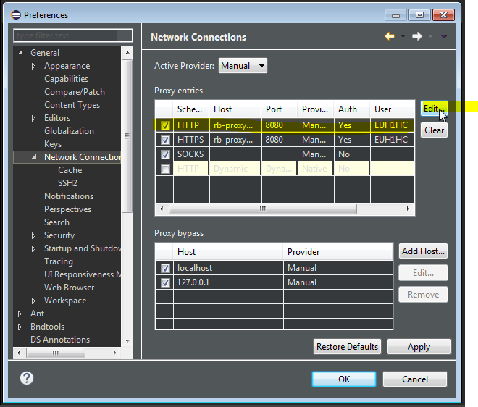

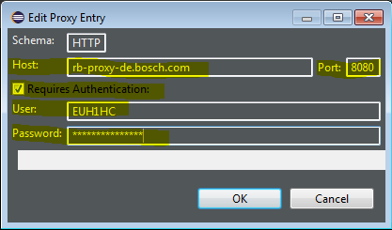

Fill out the popup window just like the image above

**Host: rb-proxy-de.bosch.com**

**Port: 8080**

**Click at the checkbox**

**User: Your User Id (which you use to login to your computer)**

**Password: Your Password**

**Then click OK**

**Also Configure For HTTPS Method**

1. At the Menu Bar, click on Help Menu and then click on Install New Update just like the picture below

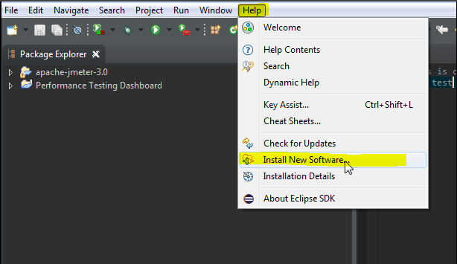

Fill out the text box “work with” with: <http://download.eclipse.org/egit/updates> to download GIT plugin for Eclipse

Wait for a sec, then click choose like the image below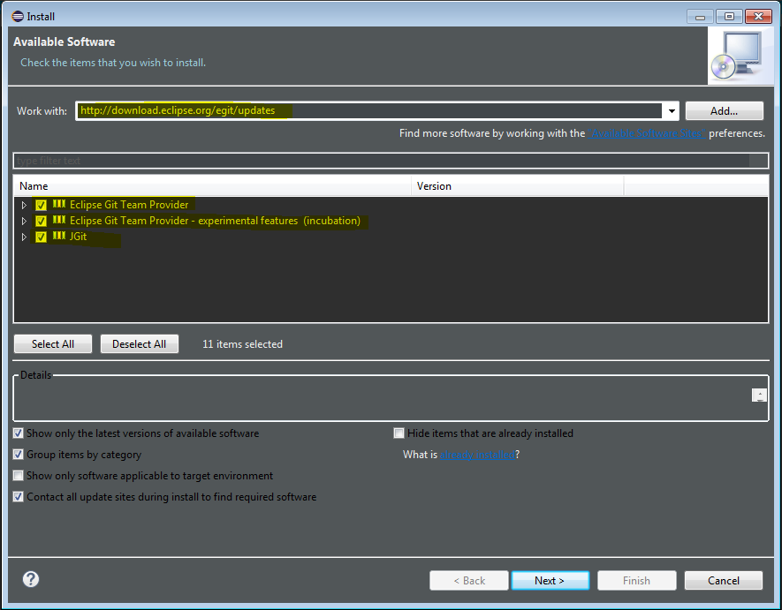

Then Click Next, Next, Next and let the machine work it works

For more information about git with eclipse, how it work or how many git’s function that you have on eclipse, go to this website for your more information:

<http://www.vogella.com/tutorials/EclipseGit/article.html#exercise-working-with-a-local-git-repository-in-eclipse>

1. Then just like step 7 open Help Menu and then click on Install New Update just like the picture below



But in this step, Fill out the text box “work with” with: **http://dl.microsoft.com/eclipse/** to download TFS plugin for Eclipse which called TEE

Wait for a sec, then click choose like the image below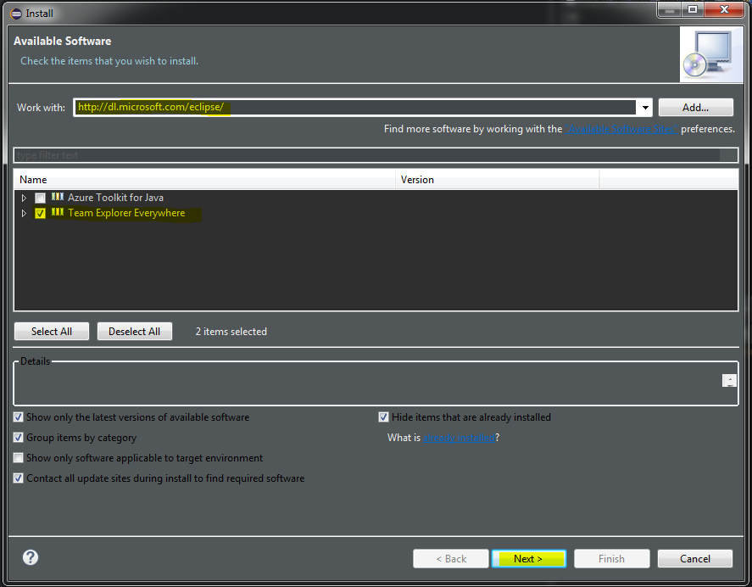

**Click Next, Next, Accept the License And Finish**

Clone repository From TFS

There are two way to clone from TFS : By GIT command and By TEE

First by GIT :

* From menu bar , click on Window -> Show View -> Other…

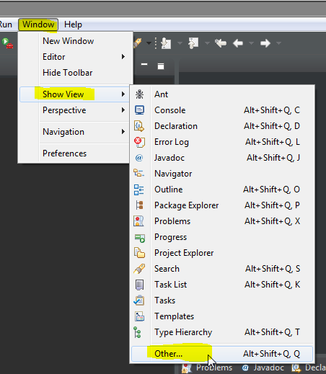

* Choose GIT folder -> Git Repositories -> OK

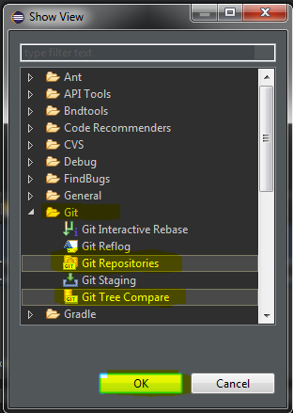

* A Git Repositories window will show up, click to this Icon to clone a repository.

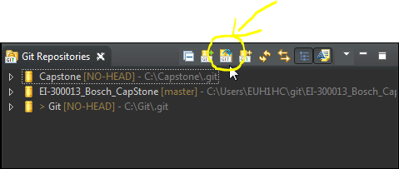

* Go to your TFS to get Clone link

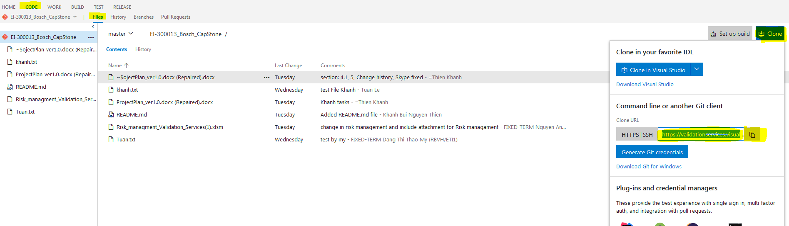

Then paste it into new window popup in STS

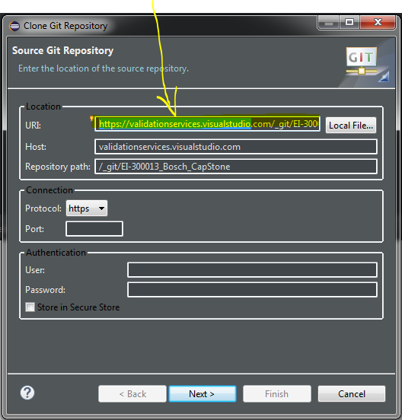

* Fill out with your user and password then click next

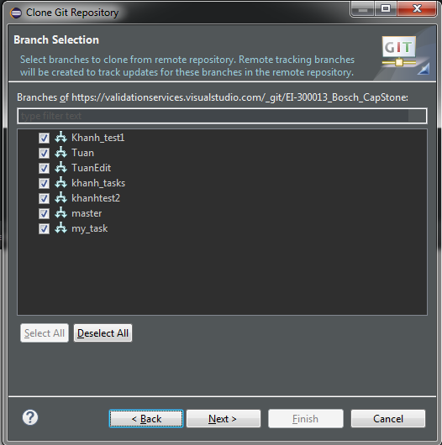

* Select all to clone all branch you get on TFS or just choose what Branch that you want to clone -> Next

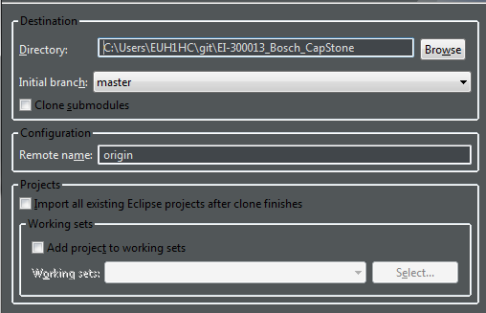

* Choose where to store your file -> Finish

Second Clone By TEE

* From menu bar , click on Window -> Show View -> Other…



* Scroll down, choose Team Foundation Server -> Team Explorer -> OK

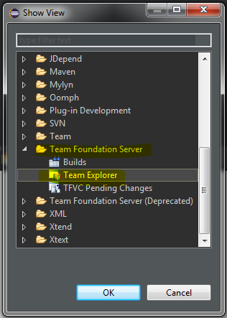

* A new Team Explorer will show up , Click on Home dropdown menu -> Projects -> Connect to Team Projects……

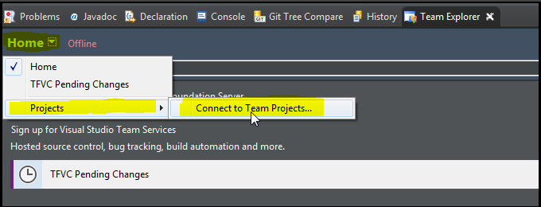

* Click on Check box Connect to a TFS or TS account, then click Servers to add new servers

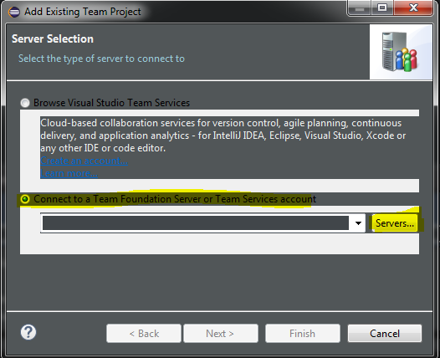

* Click add button to add new server then Copy your Clone link (which u get from TFS) then Paste it in Name or URL of Team Foundation Server:
* **Noticed: I have stuck many time in this step because Bosch Proxy didn’t followed us to do this, if you cannot add, Just try it again**

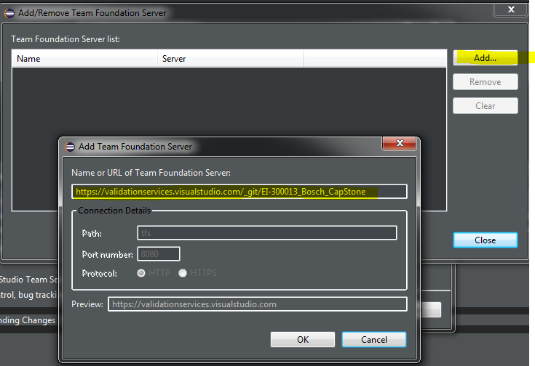

* Fill out with your email and password

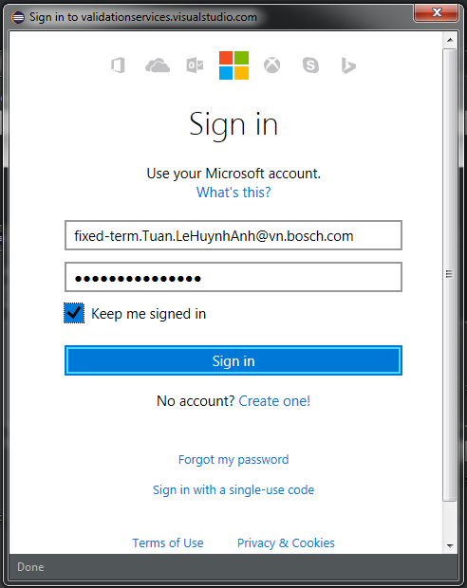

* After you signed in, your server has been added, close it and click Next
* Choose project that you want to get -> Finish

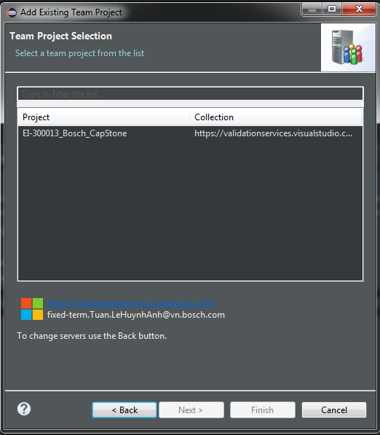

* **Noticed: if you have some error just like cannot connect thought http proxy rb-proxy-de.bosch.com etc. Try again, if still have that error, restart your computer.**
* After you connect to TFS , choose Git repositories -> your project -> import Repository

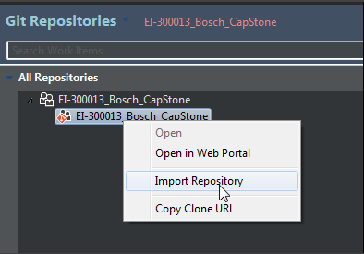

* Choose where to store your file -> Next

